The Survey Says:

Attention: Walton County School District Parents
School Quality and Improvement Survey

Walton County Public Schools is required to obtain annual input from our parents/caregivers. This survey is designed to help identify our District’s strengths and opportunities, to gather input on parent/guardian training needs for 2017-2018, and to gain insight on overall program performance.

Parents/caregivers may access the survey online from
January 23, 2017, through February 28, 2017,
on-line at: https://goo.gl/h6ig5o

Paper copies of the survey are also available in the front office of our schools.

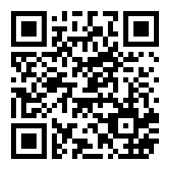

WE NEED YOUR HELP WITH THIS IMPORTANT SURVEY!
As an educational partner, we value your input and participation in the school planning and improvement process. For additional information, contact Eleanor Scott, Federal Program Director at escott@walton.k12.ga.us or call 770-266-4486.

